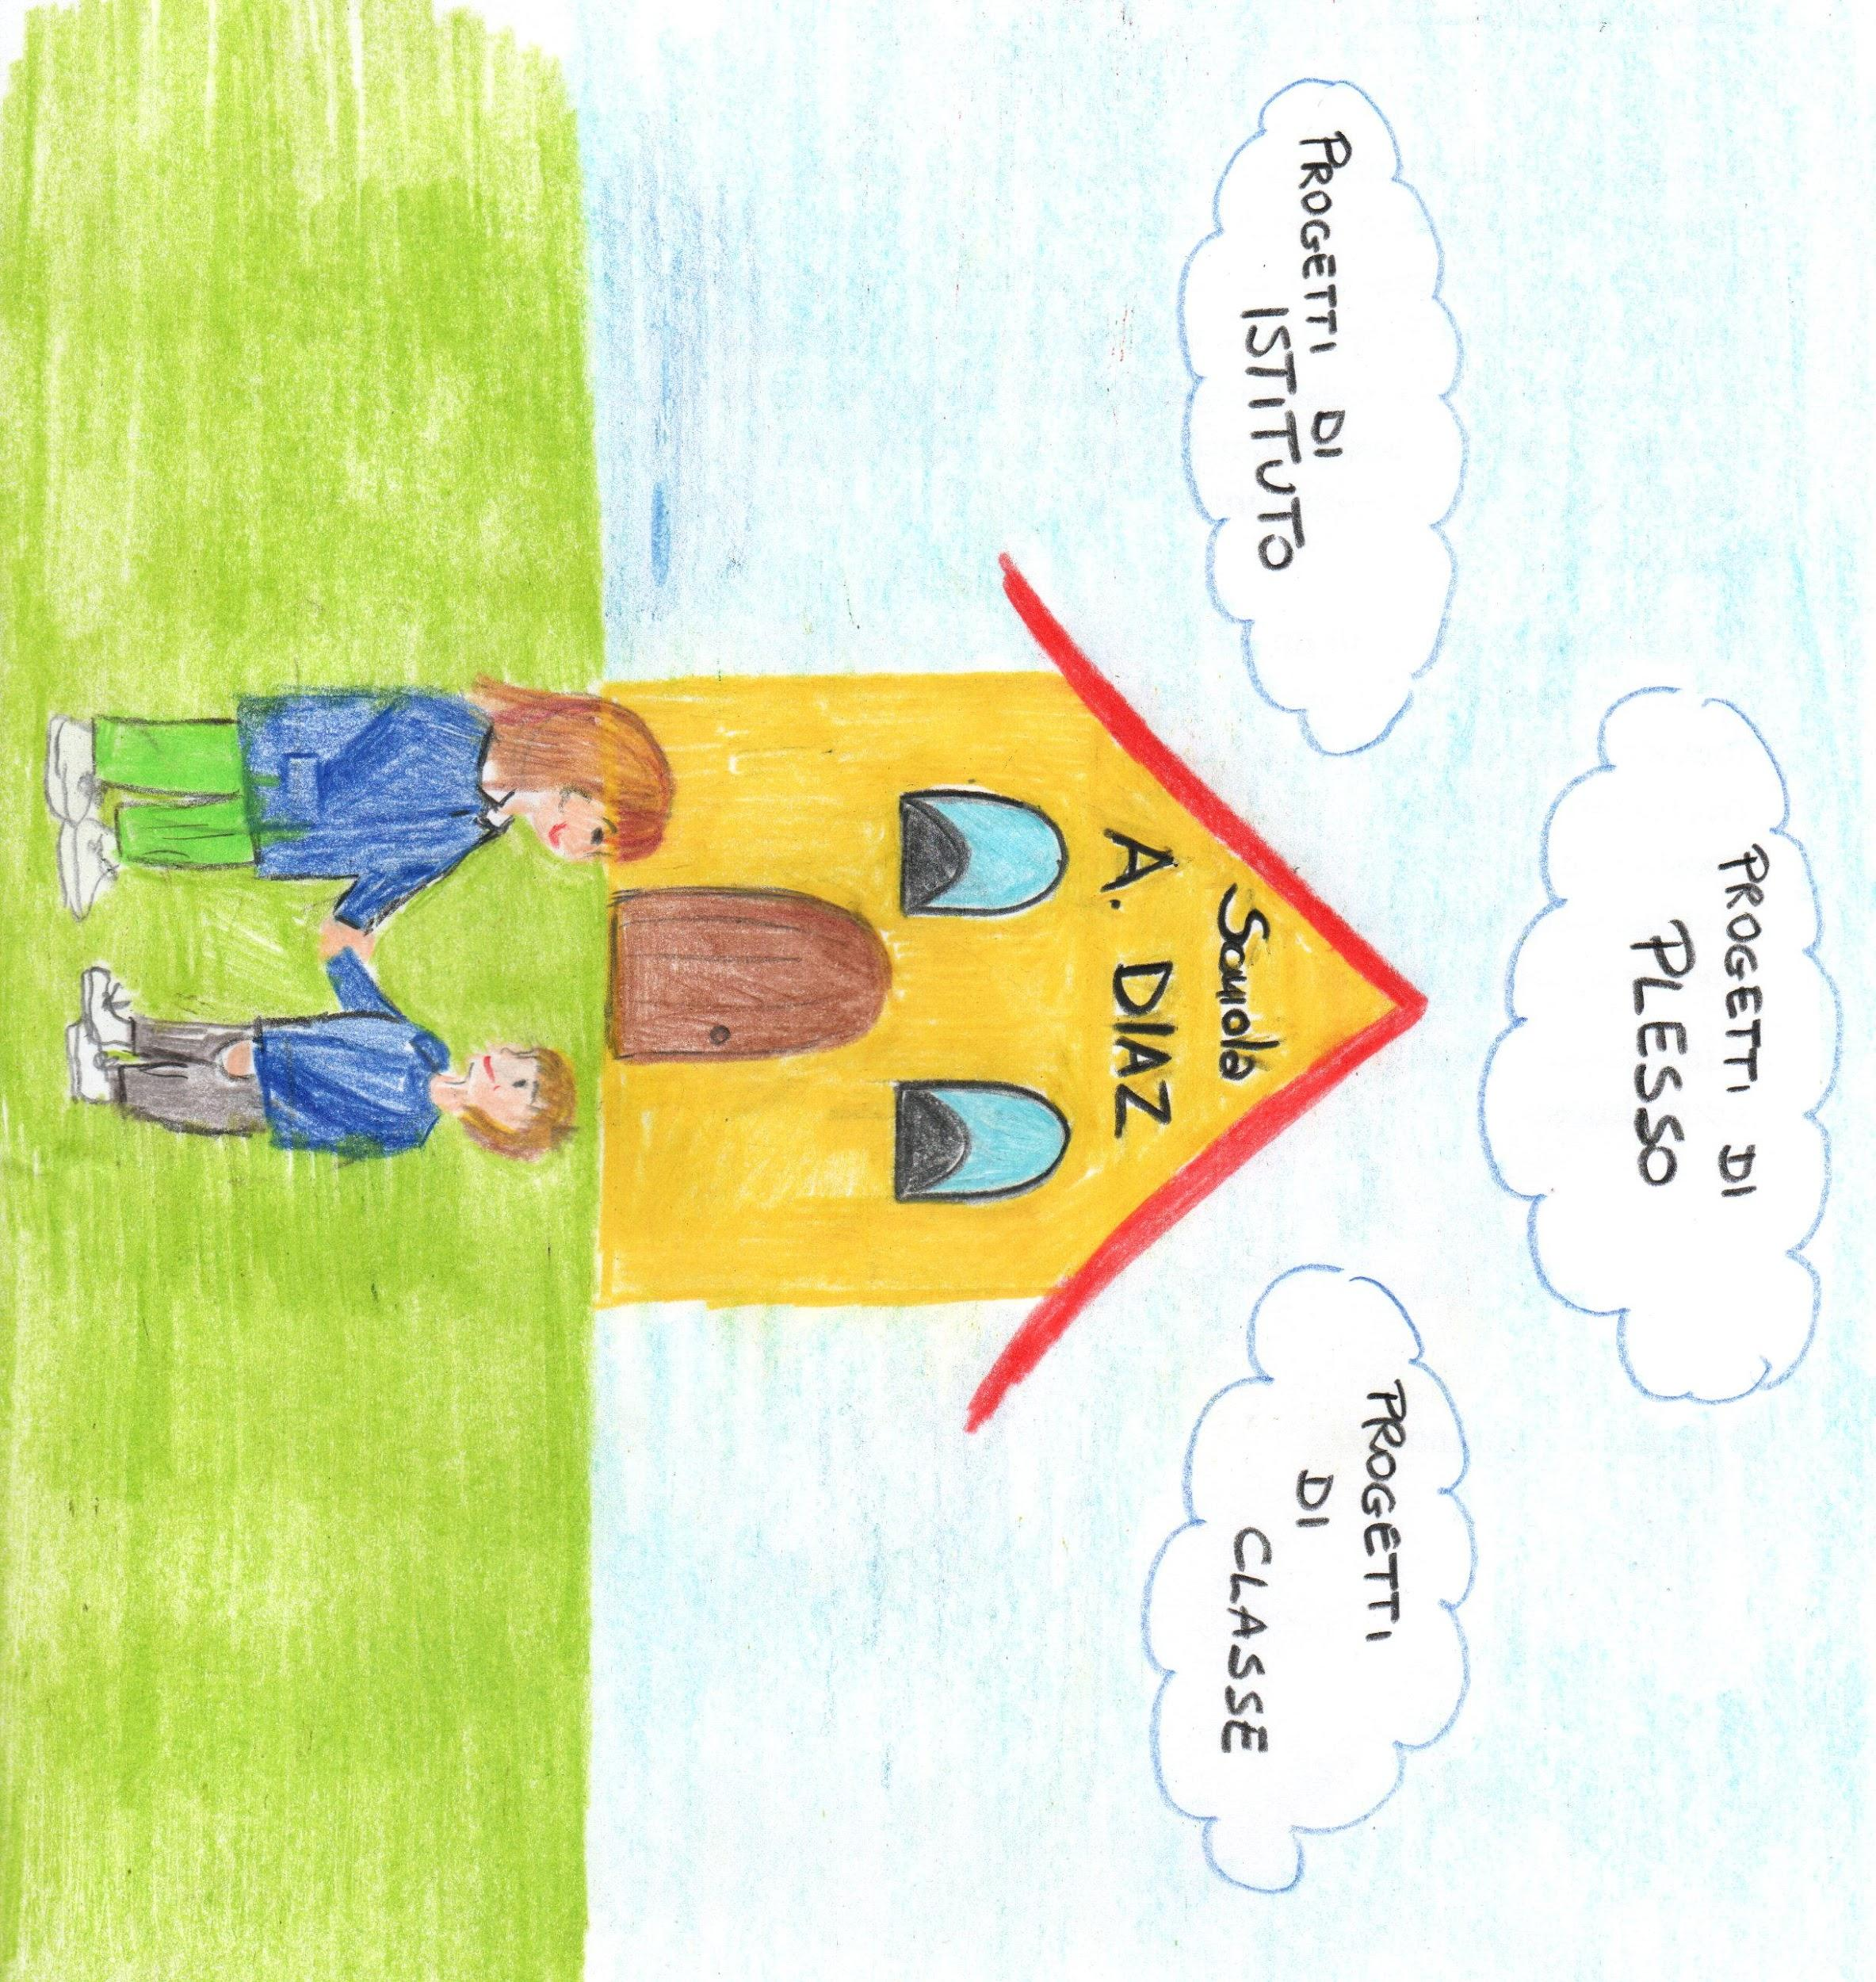

<https://docs.google.com/document/d/1WfsIVHC6Ev2BB9tli2Za2RWrVh51bnq5/edit?usp=sharing&ouid=117974522987561148364&rtpof=true&sd=true>

<https://docs.google.com/document/d/1pkGyxEpi19BLtgsmM1oANEeuU6lc7tAI/edit?usp=sharing&ouid=117974522987561148364&rtpof=true&sd=true>

<https://docs.google.com/document/d/1r2W5fzm1th-1kBD7JXUVwN8eFMInRv4h/edit?usp=sharing&ouid=117974522987561148364&rtpof=true&sd=true>